 

**School Of Mechanical & Manufacturing Engineering(SMME)**

**Assignment # 0 1**

**Course Instructor: Dr Jawad Khan**

**Lab Instructor: Muhammad Affan**

**Student Name: M.Touseef Akhtar**

**CMS ID: 460700**

# TASK 1:

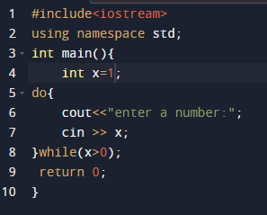

# TASK 2:

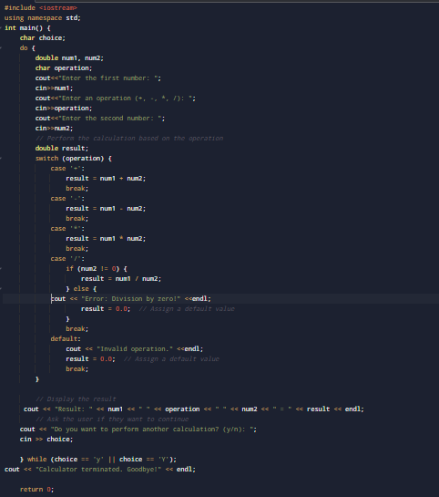

# RESULTS:

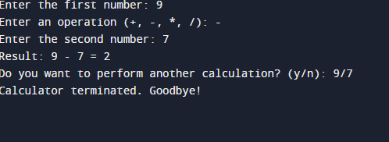

# TASK 3(a):

# RESULTS:

# 

# TASK 3(b):

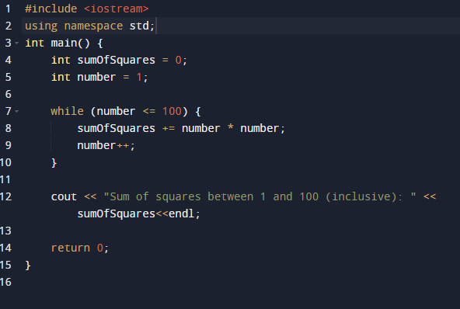

# Result:

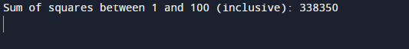

# Task 4(a):

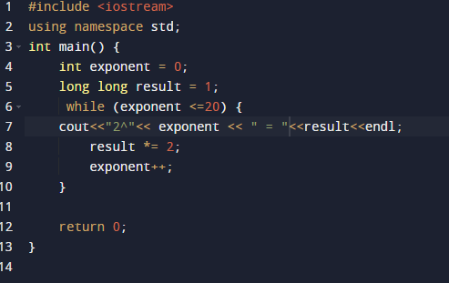

# Result :

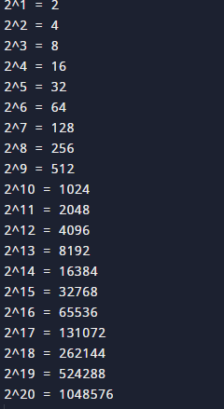

# Task 4(b):

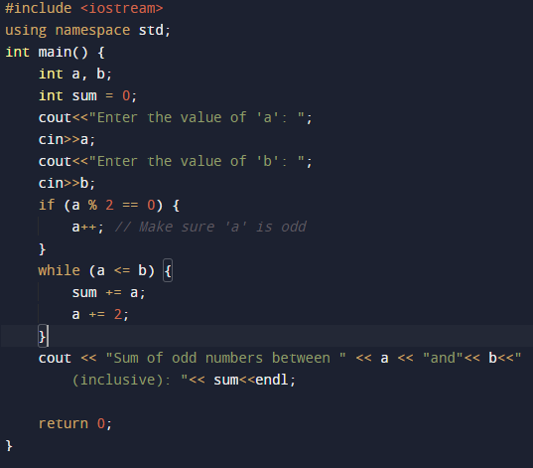

# Result:

